Automatic Barrier Gate System

Description:
The Automatic Barrier Gate System is a simple automation project used to control a vehicle entry barrier. An ultrasonic sensor detects the presence of a vehicle near the gate. When a vehicle is detected within a certain distance, the Arduino sends a signal to a servo motor which lifts the barrier (straw) upward to allow the vehicle to pass. After a few seconds, the barrier automatically returns to its original position.
Block Diagram:
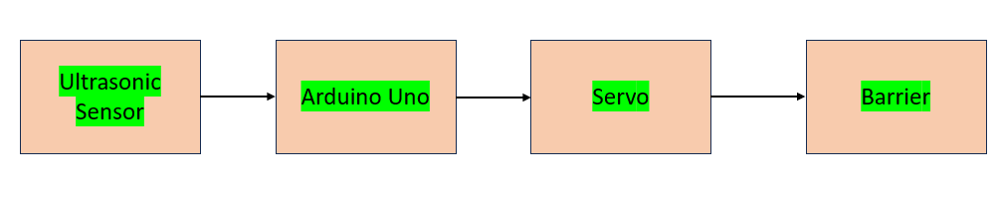
Pinout / Circuit Connection:
Ultrasonic Sensor (HC-SR04) → Arduino
Ultrasonic Pin | Arduino
VCC | 5V
GND | GND
TRIG | D9
ECHO | D10
Servo Motor → Arduino
Servo Wire | Arduino
Red | 5V
Brown/Black | GND
Orange/Yellow (Signal) | D6

Components Required:
- Arduino UNO
- Ultrasonic Sensor (HC-SR04)
- Servo Motor (SG90)
- Straw (used as barrier gate)
- Breadboard
- Jumper wires
- Power supply / USB cable
Working Principle:
The ultrasonic sensor measures the distance between the sensor and nearby objects using ultrasonic sound waves. When a vehicle approaches within a specific distance, the sensor detects it and sends the signal to the Arduino. The Arduino processes the signal and commands the servo motor to rotate and lift the barrier. After a short delay, the servo rotates back and lowers the barrier again.
Operation (Step-by-Step):
- Power ON the Arduino system.
- The ultrasonic sensor continuously measures the distance.
- When a vehicle approaches within the preset distance, the sensor detects it.
- Arduino sends a signal to the servo motor.
- The servo motor rotates and raises the straw barrier.
- After a few seconds, the barrier lowers automatically.
Arduino Code:
#include <Servo.h>

#define trigPin 9
#define echoPin 10

Servo barrierServo;

void setup() {
pinMode(trigPin, OUTPUT);
pinMode(echoPin, INPUT);
barrierServo.attach(6);
Serial.begin(9600);
}

void loop() {

long duration;
int distance;

digitalWrite(trigPin, LOW);
delayMicroseconds(2);

digitalWrite(trigPin, HIGH);
delayMicroseconds(10);
digitalWrite(trigPin, LOW);

duration = pulseIn(echoPin, HIGH);
distance = duration * 0.034 / 2;

Serial.print("Distance: ");
Serial.println(distance);

if (distance <= 15) {
barrierServo.write(90); // Lift barrier
delay(3000);
} else {
barrierServo.write(0); // Lower barrier
}

delay(500);
}
Conclusion:
The Automatic Barrier Gate System demonstrates a simple automation system used for vehicle entry control. By combining an ultrasonic sensor and servo motor, the system automatically opens and closes the barrier when a vehicle is detected. This concept is widely used in parking systems, toll gates, and restricted area entry systems.
References:
- Arduino Project Hub – Smart Dustbin using Ultrasonic Sensor.
- Electronics Tutorials – Servo Motor Interfacing with Arduino.

